|  |
| --- |
| **CPS633 Section 07 Fall2021** |
| Lab 02 Report |
| **Buffer Overflow Vulnerability Lab**  **Name: Tusaif Azmat (group leader)**  **Student#: 500660278.**  **And**  **Name: Ankit Sodhi**  **Student#: 500958004**  **Group 04.** |

**CPS 633 - Lab 2 Report**

**Buffer Overflow Vulnerability Lab**

**Lab Tasks:**

**2.1 Turning Off Countermeasures.**

**Answer: We could do that with the help of the following command.**

**$ sudo sysctl -w kernel.randomize_va_space=0**

**2.2 Task 1: Running Shellcode**

**Answer: We will follow the steps as below:**

**> ls -l /bin/sh**

**We will change the version first**

**>sudo ln -sf /bin/zsh /bin/sh**

**Now we are ready to run the cshell.c code first to set up for the next step**

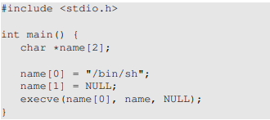

**By**

**> gcc cshell.c -o cshell**

**> ./cshell**

**>$ id**

**This will show the which shell we are running the code**

**>$exit**

**We change this to the root shell**

**>sudo chown root**

**>sudo chmod 4755 cshell**

**Check to see if it works**

**>ls -l cshell**

**Again we run the cshell.c**

**> ./cshell**

**>#id**

**This will show us that it is running in root shell**

**>#exit**

**Now we are ready to call the shellcode from the buffer**

**We construct the buffer with this call_shellcode.c**

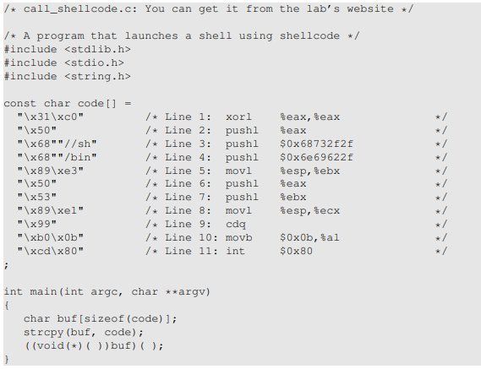

**We first create the executable for the call_shellcode.c**

**>gcc call_shellcode.c -o call_shellcode**

**It will not work so we use the following command**

**> gcc call_shellcode.c -z execstack -o call_shellcode**

**We execute our file**

**> ./call_shellcode**

**>$exit**

**It works fine now we will move to the next step.**

**2.3 The Vulnerable Program**

**Answer: We changed the file stack.c so that we could have a buffer overflow situation.**

**In the program stack.c we will increase the buffer size value to something in between 0 and 400.**

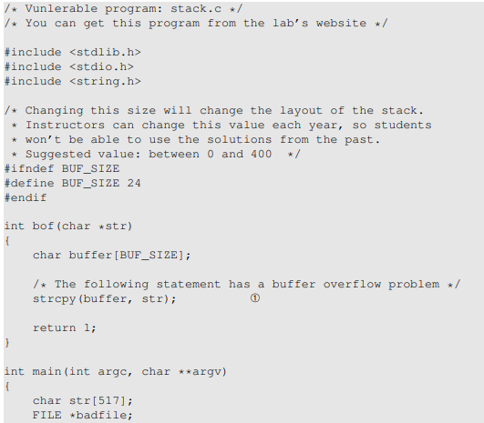

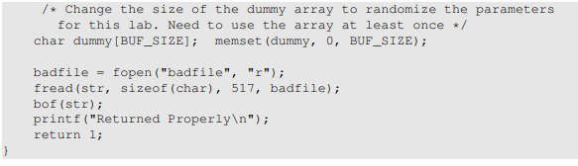

**Before executing the above program we create a badfile which will case the buffer to overflow.**

**>touch badfile**

**>ls -ls badfile (it's an empty file to start with)**

**We run the badfile first to check if it works with stack.c**

**>gcc -fno-stack-protector -z execstack stack.c -o stack**

**>Returned Properly**

**So, it shows working fine.As it's empty so no buffer overflow.**

**We check the permissions to make sure it will work properly once we later modify**

**> sudo chown root stack**

**> sudo chmod 4755 stack**

**>ls -l stack**

**>./stack**

**>Returned Properperly**

**Now we are ready for the next step.**

**2.4 Task 2: Exploiting the Vulnerability**

**Answer: We need to change the buffer size in the stack.c file to 240.**

**As you see below.**

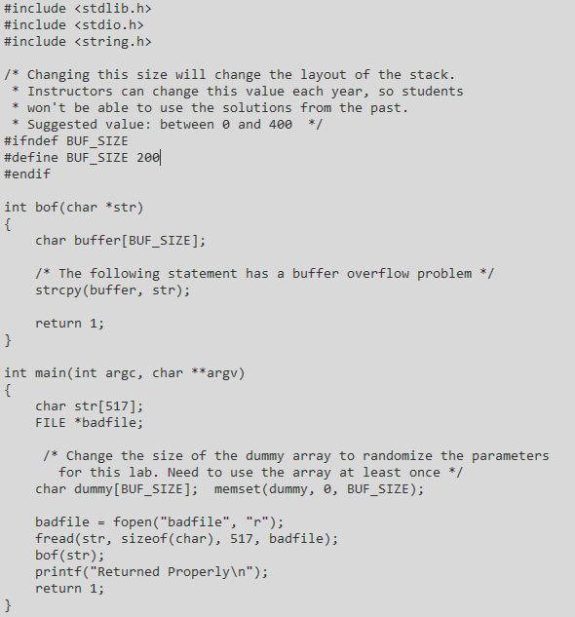

**We will use exploit.c file for this purpose. But first we need to figure out the start and return address of the vulnerable function “bof” in stack.c file. In stack.c we use buffer overflow.**

**But first we need to debug the stack.c to find the required addresses to use in exploit.c.**

**>gcc -g -fno-stack-protector -z execstack stack.c -o stack_dbg**

**> gdb ./stack_dbg**

**We get in debug mode, We use breakpoint to get the addresses.**

**> gdb-peda$ b bof**

**…**

**> gdb-peda$ run**

**…**

**>gdb-peda$ p/x &buffer**

**>$1 = 0xbfffe830**

**>gdb-peda$ p/x $ebp**

**>$2 = 0xbfffe928**

**>gdb-peda$ p/d 0xbfffe928 - 0xbfffe830**

**>$3 = 248**

**>gdb-peda$ q**

**Now we have the offset number 248 which we will use for the exploit.c file.**

**Following is the exploit.c with the required code.**

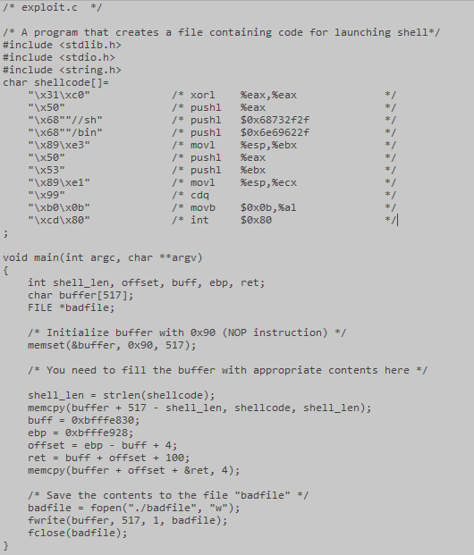

**Finally we run the code**

**>gcc exploit.c -o exploit**

**>./exploit**

**It lonches the attack**

**We check the stack.**

**>./stack**

**>#id**

**This gives id as root, that means attach runs successfully.**

**>#exit**

**2.5 Task 3: Defeating dash’s Countermeasure**

**Answer: For this task we need to set up our files as provided in the lab manual.**

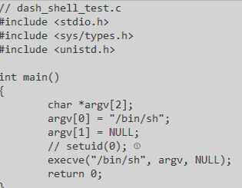

**We write the dash_shell_test.c and comment out the setuid(0) and see the effects of that…**

**First we check if our shell points to dash shell**

**> ls -l /bin/sh**

**And it showed it points tp /bin/dash**

**Now we run the first tial with setuid(0) as commented out.**

**> gcc -o dash_shell_test1 dash_shell_test.c**

**>./dash_shell_test**

**>$id**

**…**

**>exit**

**And it gives uid as 1000 that is not root. So we try changing that as follows**

**>sudo chown root dash_shell_test1**

**>sudo chmod 4755 dash_shell_test1**

**After setting up the permissions we run the file again.**

**>./dash_shell_test1**

**>$id**

**…**

**>exit**

**It still gave uid as 1000 that is the cause of commented out setuid(0). Counter measure stopping the use of root.**

**Now, we have to defeat that by un-comment the setuid(0) in our program dash_shell_test.c file**

**Again we compile and run our file dash_shell_test.c**

**>gcc -o dash_shell_test2 dash_shell_test.c**

**>./dash_shell_test2**

**>$id**

**…**

**>$exit**

**It still gives us uid=1000 so we need to change owner to root as follows**

**>sudo chown root dash_shell_test2**

**>sudo chmod 4755 dash_shell_test2**

**We run again**

**>./dash_shell_test2**

**>$id**

**…**

**>exit**

**This time we get uid as root. Now we need to attack again. So we will use a python file to initiate our attack but first we add 4 more lines to it as provided to us in the lab requirements.**

**Exploit.py**

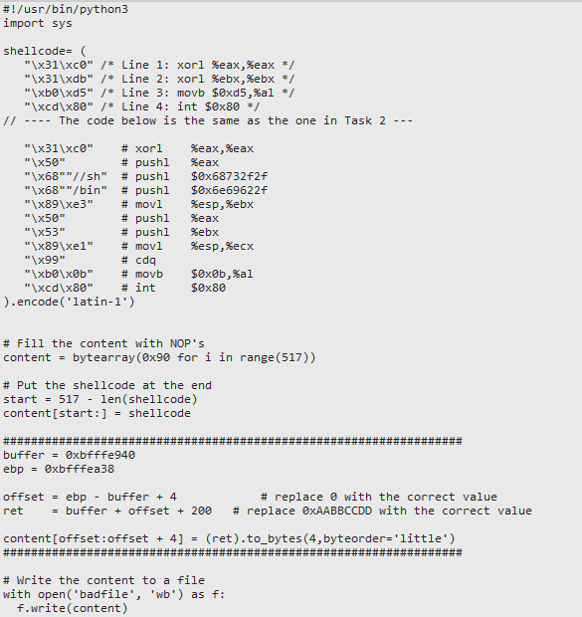

**We generate badfile with the above python file**

**We got the new addresses by following the steps followed in task 2. And execute the python file.**

**> python3 exploit.py**

**We run the stack next to see if attack was a success**

**>./stack**

**>id**

**…**

**> exit**

**It ran in root and the attack was successful.**

**2.6 Task 4: Defeating Address Randomization**

**Answer: for this task first we turn off the randomization address. We use the script provided with the lab as below to complete the task.**

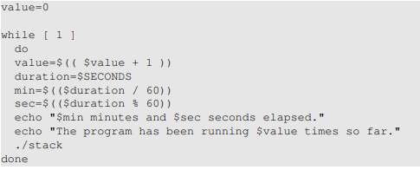

**This will run the vulnerable program an infinite number of times and exhaust the system.**

**If the attack succeeds, the script will stop; otherwise it will keep running.**

**We put our script in a file that makes it easy to run**

**Defeat_add_rand.sh**

**Again we turn off the address randomization.**

**> sudo sysctl -w kernel.randomize_va_space=2**

**We try to see**

**>./stack**

**And we run defeat_add_rand.sh**

**First we change the permissions to have it run smoothly**

**> chmod +x defeat_add_rand.sh**

**> ./defeat_add_rand.sh**

**And brute-force script will exhaust the system, we wait for the root shell back to us**

**It took a while and finally gave back the root shell as below**

**>#**

**We will try to see if we still in root shell by**

**>#id**

**…**

**>#exit**

**As we got the shell back that means our attack was successful and defeated the protection provided by the randomization.**

**2.7 Task 5: Turn on the StackGuard Protection**

**Answer: For this task as per instructions provided with the lab, first we turn off the address randomization.**

**>sudo sysctl -w kernel.randomize_va_space=0**

**Before moving forward with the next step we check the gcc version**

**> gcc --verson**

**We get it fine and stack guard protection is turned on by default**

**Then we use below to compile as stack_wsg**

**>gcc -z execstack -o stack_wsg stack.c**

**This will gives us aan executable file then we run it**

**>./stack_wsg**

**And we get the following error**

**>*** Stack Smashing detected**

**And the program will terminate.**

**That means stack guard is enabled and stops the attack.**

**Now we change shell to root to see if it works that way.**

**>sudo chown root stack_wsg**

**> sudo chmod 4755 stack_wsg**

**Now its owner is root and we run the program again.**

**> ./stack_wsg**

**And it gives the same error “Stack Smashing detected” and the program terminates.**

**That means it is overridden.**

**2.8 Task 6: Turn on the Non-executable Stack Protection**

**Answer: First we turn off the address randomization as usual.**

**In this task, we recompile our vulnerable program using the noexecstack option, and repeat the attack in Task 2.**

**For executable of attack file we use name as stack_n_ex**

**> gcc -o stack_n_ex -fno-stack-protector -z noexecstack stack.c**

**Once the executable is created we run as program using the shell**

**>./stack_n_ex**

**We get “fragmentation fault”**

**That means even though the buffer is full it goes to non-executable stack**

**The malicious code is placed in non-executable stack**

**We try to change the permissions to see if it changes anything**

**>sudo chown root stack_n_ex**

**>sudo chmod 4755 stack_n_ex**

**We tried again**

**>./stack_n_ex**

**But we still get the same message “fragmentation fault”. It means task 2 attack failed.**